Mental Disorders Visual Aid:
DEPRESSION: SAD, HOPELESS

PERSONALITY DISORDER: CAN SEEM LIKE DIFFERENT PEOPLE AT TIMES, TROUBLE WITH RELATIONSHIPS, UNCOMFORTABLE IN SOCIAL SITUATIONS
CONDUCT DISORDER: DOES NOT FOLLOW SOCIAL RULES, CAN BE AGGRESSIVE, VIOLENT, STEAL, LIE
COMPULSIVE SHOPPING: SPENDING ON ITEMS YOU DON’T NEED WITH MONEY YOU DON’T HAVE.
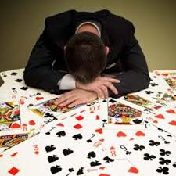 EXCESSIVE GAMBLING: NO CONTROL OVER THEIR MONEY WHEN IT COMES TO GAMBLING, BETTING, ETC. THEY’LL RISK IT ALL.
OCD: CONSTANT CHECKING, WASHING, ORGANIZING, COUNTING KEEP THE PERSON FROM LIVING A NORMAL LIFE.
PANIC: SWEATING, SHORTNESS OF BREATH, SHAKING BECAUSE OF A SPECIFIC TRIGGER (PUBLIC SPEAKING).
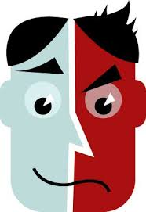 BIPOLAR: EXTREME MOOD SWINGS IN A SHORT AMOUNT OF TIME. HAPPY THEN MAD.

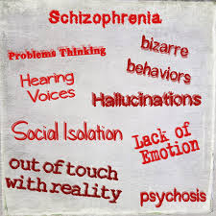 SCHIZOPHRENIA: SEEING, HEARING PEOPLE THAT AREN’T THERE, THINKING PEOPLE ARE OUT TO GET YOU.
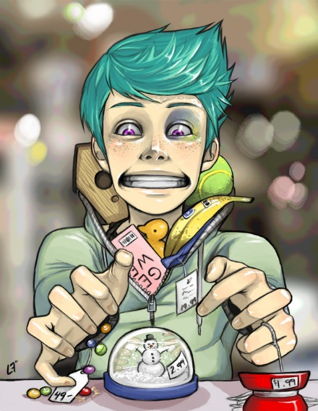 KLEPTOMANIA: STEALING ITEMS THAT YOU DON’T NEED OR WANT, UNPLANNED.
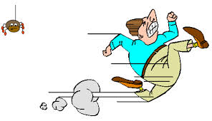PHOBIA: AN IRRATIONAL FEAR OF SOMETHING SPECIFIC

EATING DISORDER: AN IRRATIONAL OBSESSION WITH BODY IMAGE OR FOOD.
PYROMANIA: SETTING FIRES FOR PLEASURE
PTSD: NIGHTMARES AND FLASHBACKS AFTER A TERRIFYING EVENT

