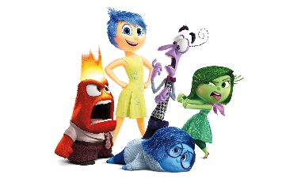
Name: _________________________________ Period: _____
Chapter 3 Lesson 3 Expressing Emotions in Healthful Ways
Inside Out Clip: https://www.youtube.com/watch?v=cnUNBR1XWRQ
https://www.youtube.com/watch?v=EMQT-Mv92x0
Music, poetry, photography, films are art forms that can be used to express emotions. Think of a time when you’ve heard a song or seen a movie that definitely aimed for creating an emotional response. For the following emotions write the name of a song and the artist or the movie and exact part of the movie that you felt the following emotions, or they were protrayed.
Happy- __________________________________________________________
Why did you select this?
______________________________________________________________________________________________________________________________________

Fear- __________________________________________________________
Why did you select this?
______________________________________________________________________________________________________________________________________

Sadness- __________________________________________________________
Why did you select this?
______________________________________________________________________________________________________________________________________

Love- __________________________________________________________
Why did you select this?
______________________________________________________________________________________________________________________________________

Anger- __________________________________________________________
Why did you select this?
______________________________________________________________________________________________________________________________________

Guilt or Jealously- __________________________________________________________
Why did you select this?
______________________________________________________________________________________________________________________________________
The Soundtrack of Your Life:

Think of 4 major specific moments/time periods of your life and come up with a song that symbolizes that moment or reminds you of it anytime you hear it. Emotions can be repeated.

Moment #1: (Give a brief explanation) __________________________________________________________________________________________________________________________________________________________
Emotion Represented: _________________________
Song that depicts that moment:___________________________________________________
Why: __________________________________________________________________________________________________________________________________________________________

Moment #2: (Give a brief explanation) __________________________________________________________________________________________________________________________________________________________
Emotion Represented: _________________________
Song that depicts that moment:___________________________________________________
Why: __________________________________________________________________________________________________________________________________________________________

Moment #3: (Give a brief explanation) __________________________________________________________________________________________________________________________________________________________
Emotion Represented: _________________________
Song that depicts that moment:___________________________________________________
Why: __________________________________________________________________________________________________________________________________________________________

Moment #4: (Give a brief explanation) __________________________________________________________________________________________________________________________________________________________
Emotion Represented: _________________________
Song that depicts that moment:___________________________________________________
Why: __________________________________________________________________________________________________________________________________________________________

Age/Grade ____ A song that reminds you of that time period every time you hear it:

