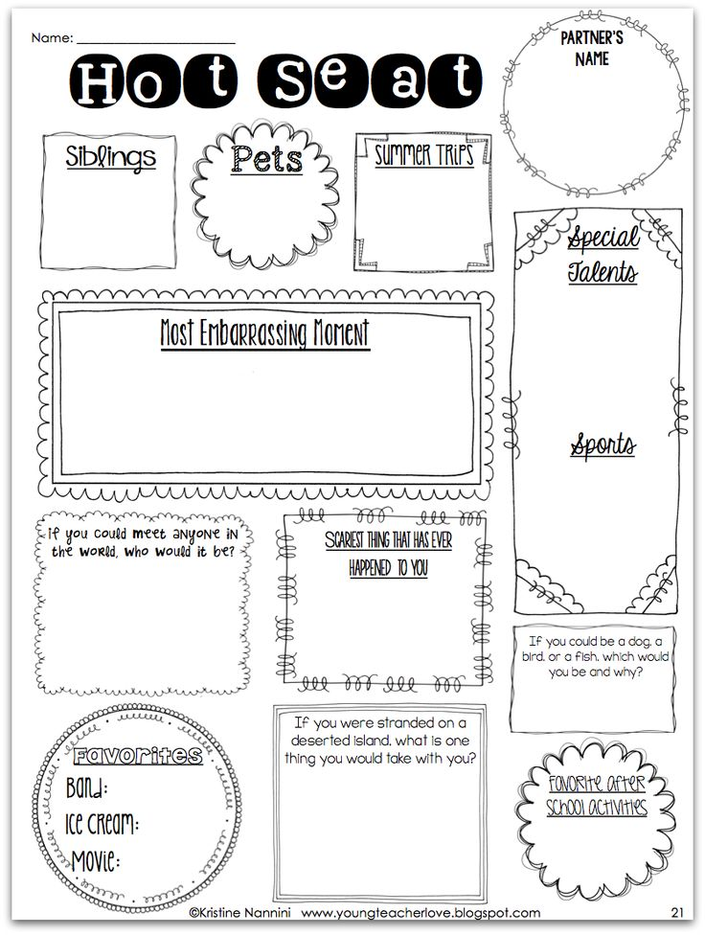

After high school I plan on…

Hobbies I have are:

My favorite book/author is:

**Pick your preference:**

**I’m Shy/I’m Outgoing**

**Group Work/Individual Work**

**I’m nervous about high school/I’m looking fwd to h.s.**

**Morning person/Night Owl**

What Disney character or candy bar best fits your personality and why?

**When I grow up I want to be a…**

**Extra Curricular Activities you plan to be a part of at NAHS:**