Name: _____________________________________________. Per: ____. My Plate Activity

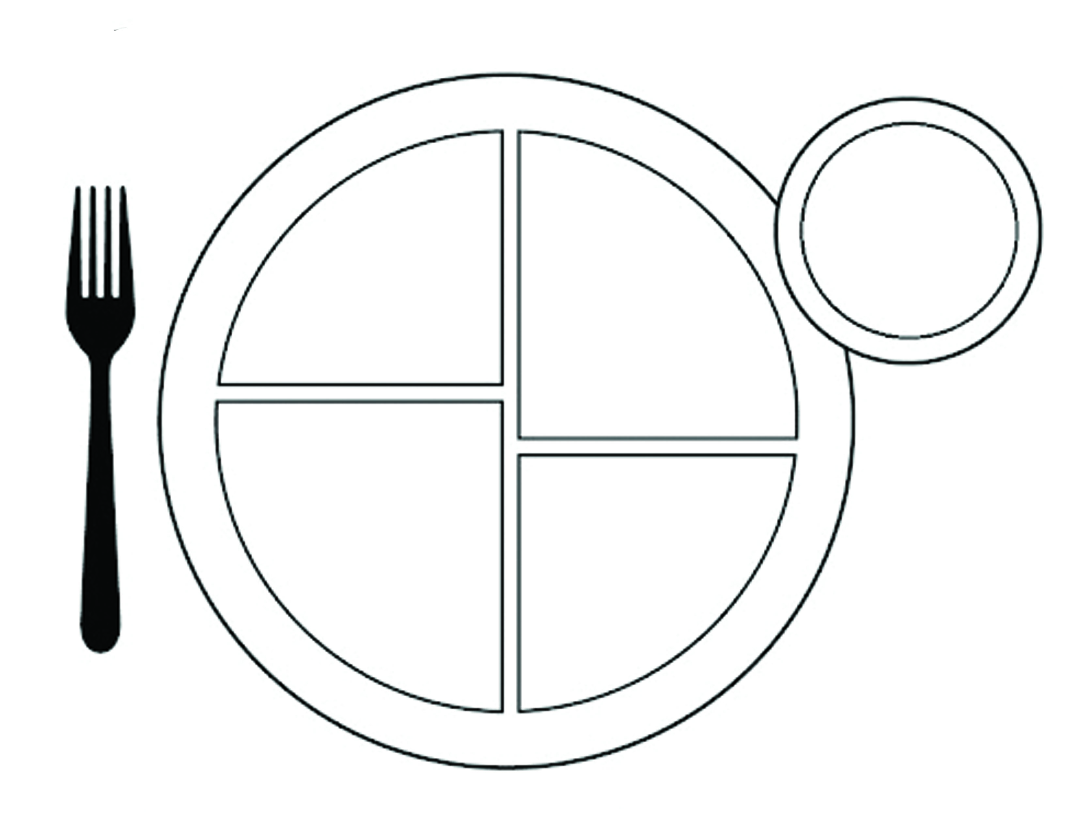
Create a typical unhealthy meal (breakfast, lunch or dinner) that teens tend to eat on the My Plate template: Now make changes to make it a healthy meal that you feel teens would enjoy eating by looking at the samples on https://www.choosemyplate.gov/budget-sample-two-week-menus

4 grams of sugar = 1 tsp. of sugar 16 grams of sugar = ____ tsp of sugar

Energy In has to match Energy Out:
Junk food and fast food a has high calorie content. Using your own device look up the following, add up the calories and then calculate specifically how many exercises you would have to do to burn off those calories.

1) A burger (your choice), medium french fry and medium soda (non-diet) from a fast food restaurant:
Restaurant-
Burger- Calories- Sugar Grams-
Medium Fry Calories- Sugar Grams-
Medium Soda- Calories- Sugar Grams-
Total Calories- Total tsp of sugar-

Amount of specific exercises you'd have to do to burn that off: go to: (www.healthassist.net for these)

2) A small blizzard (your choice) from Dairy Queen.
Type of Blizzard- Calories- Teaspoons of sugar-

Amount of specific exercises you'd have to do to burn that off:

3) Your favorite regular size candy bar.
Type of candy bar- Calories- Teaspoons of sugar-

Amount of specific exercises you'd have to do to burn that off:

4) Your favorite type of chips (1 single serving). Teaspoons of sugar-
Type of chips- Calories-

Amount of specific exercises you'd have to do to burn that off.

5) Your favorite type of non-diet soda (1 can).
Type of soda- Calories- Teaspoons of sugar-

Amount of specific exercises you'd have to do to burn that off.

